Maze Game

User Guide

HSC Software Design & Development 2022  
Major Project Stage 3 – Implementation  
36238194 IS1201

Table of Contents

About 3

System Requirements 3

Minimum Hardware Specifications 3

Recommended Hardware Specifications 3

Software Requirements 3

Installation Guide 4

Extracting the Compressed Archive (ZIP) File 4

Installing Fonts 5

Running the program 6

Visual Studio not installed 6

Running the program with Visual Studio installed 8

How to Play 9

Gameplay Instructions 9

Main Screen 10

Help Screen 10

Instructions Screen 11

Highscores Screen 11

Game Screen 12

Game Over Screen 12

Troubleshooting Guide 13

Technical Support 14

Licensing 14

Notes 15

# About

The Maze Game is a very simple game based around pathfinding and speed. The goal is to navigate from the starting cell through the maze to the finish cell. There is a single correct path between the start/finish cells, and the goal of the game is to make it through the maze as fast as possible.

# System Requirements

## Minimum Hardware Specifications

* CPU: 2 Cores, 4 Threads, 1.5GHZ
* RAM: 1GB
* Storage: 1GB
* Graphics: 500MB Integrated Graphics System supporting DirectX 10
* Monitor: 1920x1080px resolution, 100% display scaling

## Recommended Hardware Specifications

* CPU: 4 Cores, 12 Threads, 2.8GHz
* RAM: 4GB
* Storage: 10GB
* Graphics: 2GB Discrete GPU supporting DirectX 10
* Monitor: 1920x1080px resolution, 100% display scaling

## Software Requirements

* Windows 10, latest stable release
* Visual Studio 2022 Community Edition, latest stable release
* .NET Framework 5, latest stable release
* An internet connection (to download the game initially)

# Installation Guide

## Extracting the Compressed Archive (ZIP) File

1. Download the ZIP file named *Bashford Jack Stage 3.zip* from the developer’s website.
2. 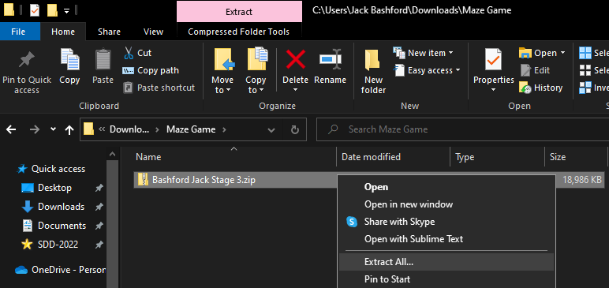Locate the ZIP file using the File Explorer program (it is likely in the Downloads folder), and then right-click and select ‘Extract All...’  
   *Figure 1: Extract All files from the compressed archive*
3. 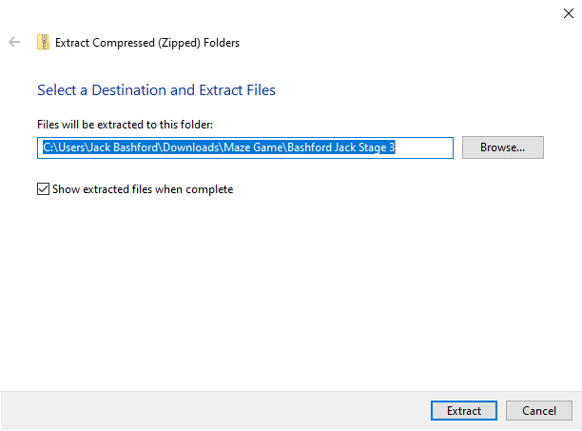In the popup window that opens, select the box labelled ‘Show extracted files when complete’ and then click ‘Extract’

*Figure 2: Extracting the compressed archive*

1. 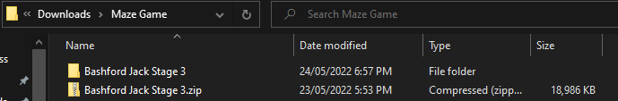The ZIP file should have now extracted into a new folder with the same name and location as the ZIP file.

*Figure 3: The original ZIP file and the expanded folder*

## Installing Fonts

1. 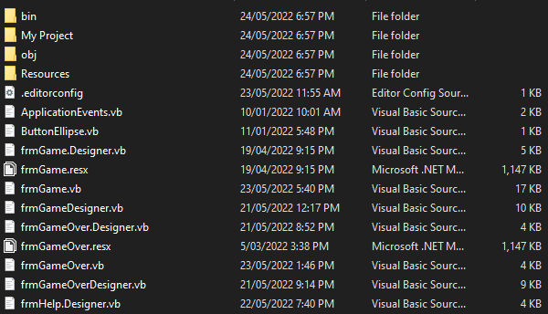Navigate into the expanded ZIP folder and the sub-folder ‘MazeGame’.

*Figure 4: Some of the contents of the ‘MazeGame’ subdirectory*

1. Navigate from this folder into the ‘Resources’ folder.
2. 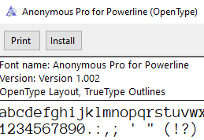There are three files in this folder – one image (a png file) and two fonts (ttf files). Double-click on one of the two fonts to bring up the installer:

*Figure 5: The installer window of the ‘Anonymous Pro’ font*

1. Click on the ‘Install’ button in the top left, then close the installer window.
2. Repeat steps 3 and 4 with the second font.

# Running the program

## Visual Studio not installed

1. Navigate into the expanded ZIP folder and the sub-folder ‘MazeGame’.
2. 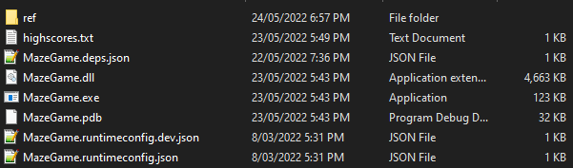Navigate from this folder to the path ‘bin\Debug\net5.0-windows’.

*Figure 6: The contents of ‘MazeGame\bin\Debug\net5.0-windows’*

1. 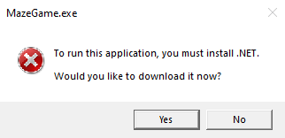The following prompt will then be displayed if you do not have .NET installed. Click ‘Yes’ and a page in your web browser will open.

*Figure 7: This prompt means you do not have .NET installed*

1. Locate the ‘Run desktop apps’ option and select your system architecture (Check ‘System Information’ in Windows Search to see what architecture your system uses). This will download an exe file.

*Figure 8: Select the appropriate architecture to download*

1. 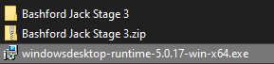In your downloads folder, locate and run the downloaded exe file.

*Figure 9: Run the newly downloaded exe file to install the .NET 5.0 Runtime*

1. The installer will now launch – select the ‘Install’ option in the bottom right, and the installation should proceed after administrator approval. Once .NET has been installed, you should see the below screen:Graphical user interface, application, Teams

   Description automatically generated

*Figure 10: The success screen shown once .NET 5.0 has been installed*

1. Follow steps 1 and 2 again to re-locate the MazeGame.exe file. This should now start the game once you run it. See ‘How to Play’.
   1. If the game does not start and still prompts you to install .NET, ensure that you’ve selected the appropriate architecture for your system. Your computer may require a restart for the changes to take effect.

## Running the program with Visual Studio installed

1. Navigate into the expanded ZIP folder and the sub-folder ‘MazeGame’. See *Figure 4* for the contents of the directory.
2. 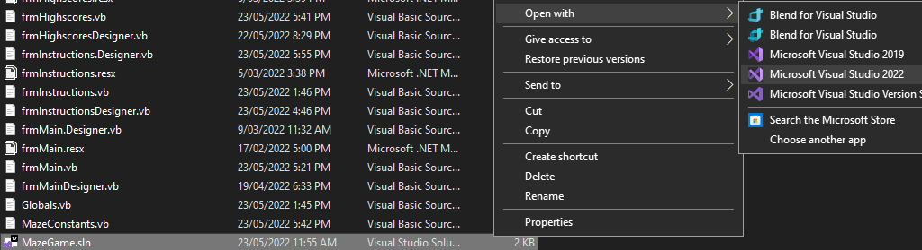Right-click the file named ‘MazeGame.sln’ and choose ‘Open With 🡪 Microsoft Visual Studio 2022’.

*Figure 11: Open the ‘MazeGame.sln’ file with Microsoft Visual Studio 2022*

1. 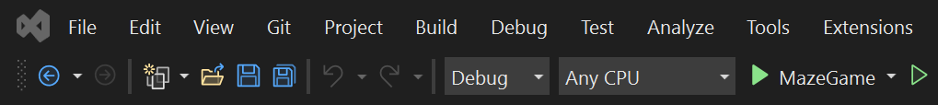Once Visual Studio 2022 opens, look at the toolbar at the top of the screen. There should be either one or two green arrows, along with the text ‘MazeGame’.

*Figure 12: The toolbar of Visual Studio 2022, and the green Build buttons*

1. 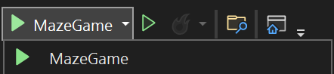If you see two buttons, click the hollow / unfilled one (the rightmost button in Figure 7), but if you only see one button, click the dropdown and select the green arrow again.

*Figure 13: The dropdown to run the game from within Visual Studio 2022*

1. The game will now start up – see ‘How to Play’.

# How to Play

## Gameplay Instructions

The objective of Maze Game is to make it from the starting cell of the maze (the top left) to the ending cell of the maze (the bottom right) in the least amount of time. On the Main Screen (pictured under ‘Main Screen’) then you can see the three input fields and three buttons available to use. You must enter a valid name (alphanumeric characters and underscores, 1-16 characters in length) and choose one of the four difficulties on the left-hand side (10x10, 20x20, 30x30, or a random choice of those three) in order to play.

If you play a non-random difficulty, you have the option to enter a maze seed. This seed is what makes your maze unique (think of it like a unique ID assigned to each maze). If you wish to, you can enter a maze seed (a hexadecimal number up to 10 digits in length), noting the same maze seed/maze size combination produces the same maze to play through. The maze is also displayed on the left during playthrough (see ‘Game Screen’) and shown after you’ve completed the game (see ‘Game Over Screen’). You can copy this seed (by double-clicking it in the ‘Game Over Screen’) and paste it back into the ‘Main Screen’ field if you would like to try playing the same maze again (just make sure you select the same maze size).

A simplified, in-game set of these instructions is available from the ‘Main Screen’ if you click the ‘Instructions’ button (see ‘Instructions Screen’), and an online help screen is accessible on every form through the F1 key (see ‘Help Screen’).

Once you’ve selected the difficulty and entered a name (and optionally chosen a seed) you can play the game. Click ‘Play’ and use the arrow keys or your on-screen gamepad to navigate through the maze. Once you complete the game, you’ll be provided with a game summary, and the option to view the highscores for each maze size (see ‘Highscores Screen’) and the option to quit the game (if you’d like to play again, copy the seed if desired, then quit and restart the game as detailed in ‘Running the Program with/without Visual Studio Installed’ as required.

Note you cannot take longer than 1 hour to complete the maze, so if you cannot complete a hard difficulty, perhaps try an easier/smaller maze.

See Figures 14-19 below for each of the six game screens.

## Main Screen

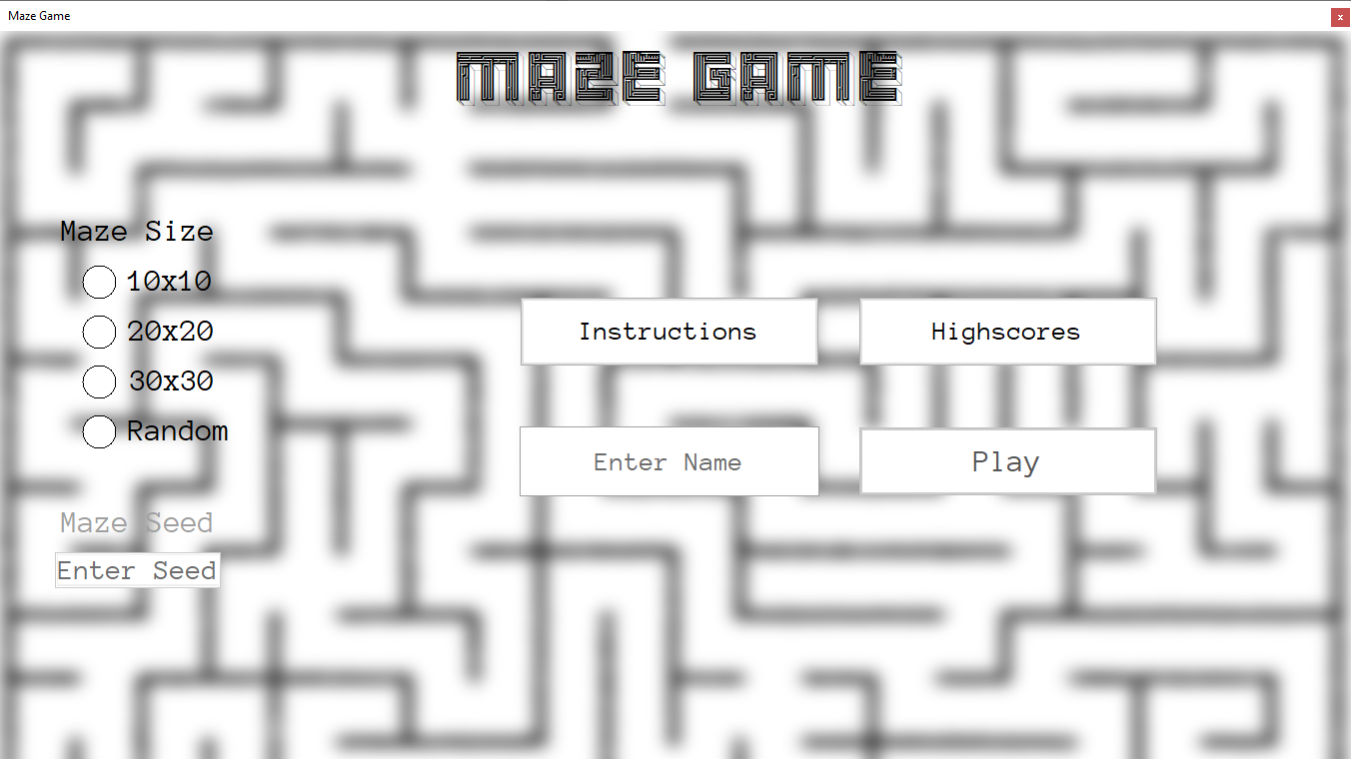

This form is shown to you when you first start the game.

## Help Screen

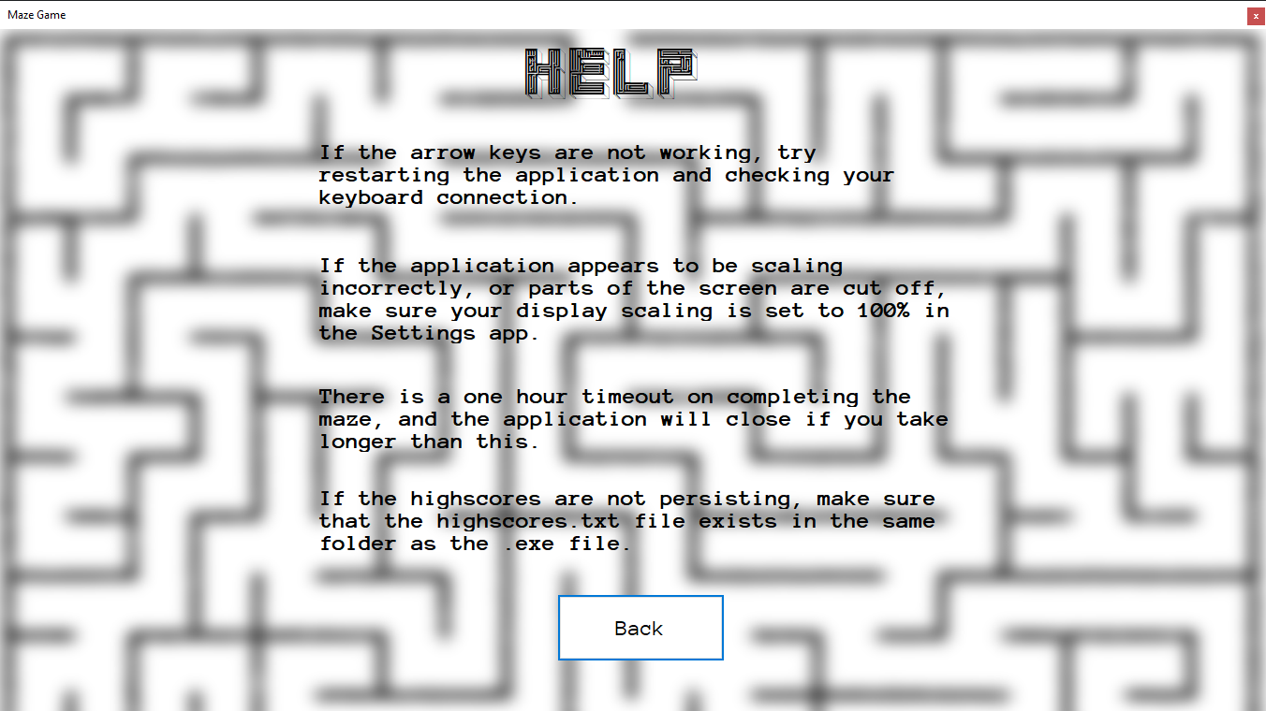

This form will be displayed when you press the F1 (help) key on any of the other screens.

## Instructions Screen

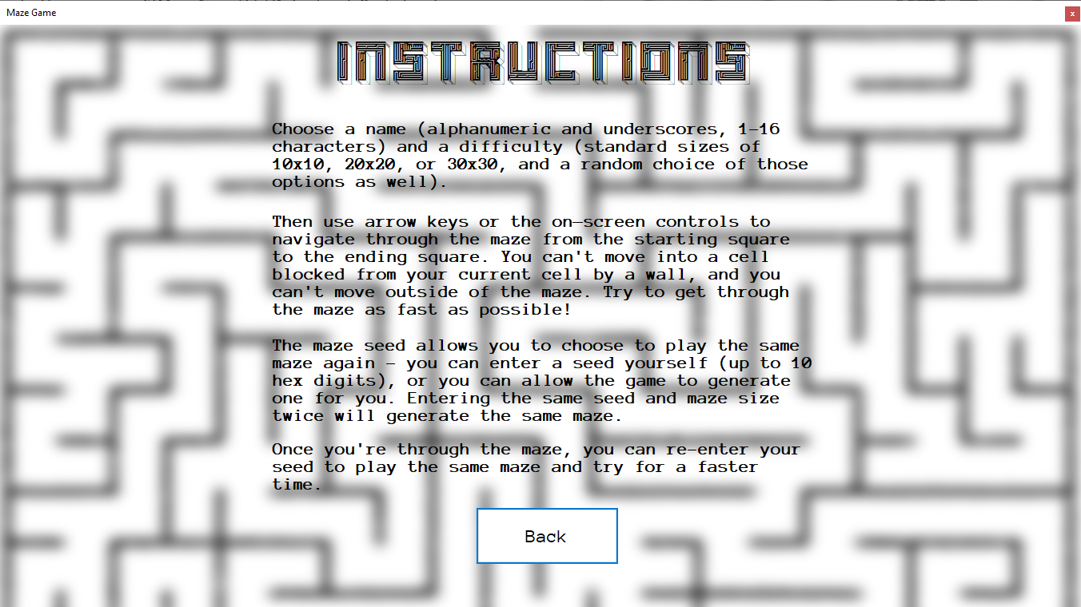

This form is shown when you click the ‘Instructions’ button on the Main Screen.

## Highscores Screen

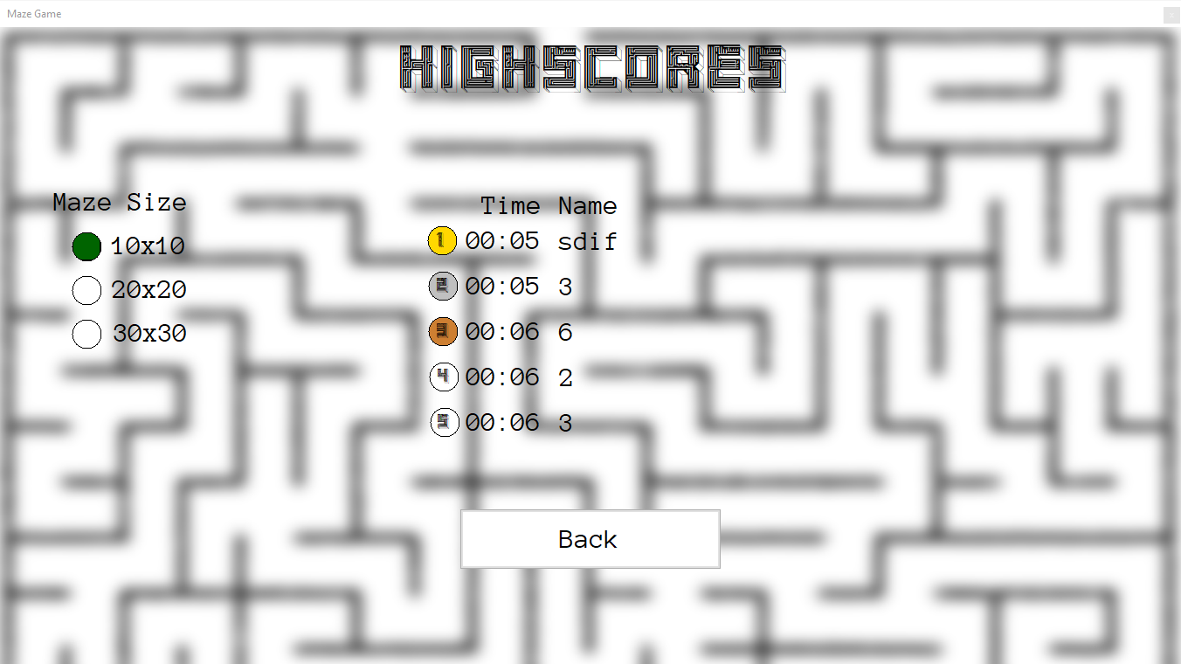

This form can be accessed via the ‘Highscores’ button on either the Main Screen or the Game Over Screen.

## Game Screen

This form is shown when you start playing the game from the Main Screen.

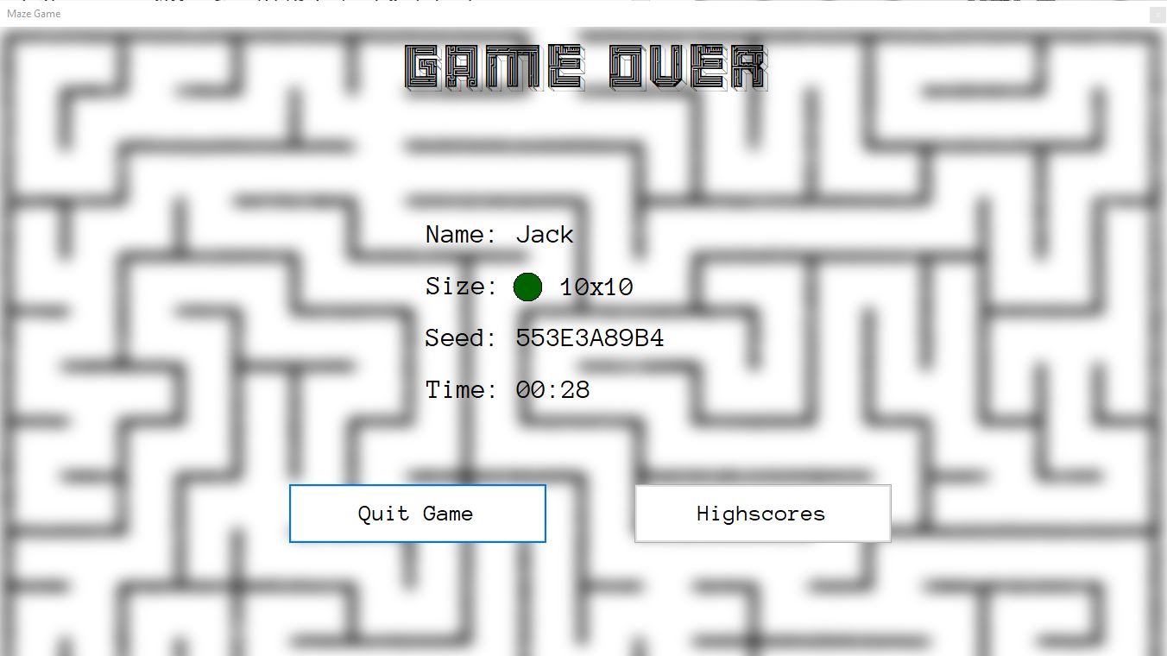Game Over Screen

This form is shown once you make it through the maze on the Game Screen.

# Troubleshooting Guide

|  |  |  |
| --- | --- | --- |
| **Error** | **Likely Cause of Error** | **How to Resolve Error** |
| Unable to Start Game | Invalid name or seed entered (this will gray out the Play button).  Difficulty not selected (will show a message). | Ensure your name and/or seed entries match the requirements outlined in the Instructions screen.  Ensure you have selected a difficulty level. |
| Unable to Use Arrow Keys | Keyboard incorrectly connected / configured. | Ensure your keyboard is plugged into your computer correctly, and that the keys you are pressing are mapped to the arrow keys. |
| Highscores Changed or Empty | highscores.txt file moved, deleted, or renamed. | Ensure you have not moved, renamed, or deleted the highscores.txt file from its original location (see Figure 5).  Redownload and reinstall game if needed. |
| Screens/Forms Cut Off | Windows scaling incorrectly assigned, or resolution too low. | Ensure your Windows scaling is set to 100% in the Settings application (System 🡪 Display), and that your display resolution is at or above 1920x1080px. |
| Unexpected crash or other error message | Unknown | Contact developer (see ‘Technical Support’). |

## Technical Support

Developer contact information.

|  |
| --- |
| Jack Bashford  Year 12 Software Design & Development Class of 2022, Canberra Grammar School Email: Jack.Bashford@cgs.act.edu.au |

Please contact if technical support is required.

# Licensing

This product is only to be used in specific educational circumstances or for personal, non-commercial use (at the discretion of the developer, Jack Bashford). No modification of any program file (including all source code, executables and compiler files, documentation, or any other file included/bundled with this program) of any kind is permitted. If you require changes to be made to the program, please contact the developer, Jack Bashford.

Redistribution of the program, for no cost and in adherence to the above modification rules, is permitted if and only if this license and documentation are kept intact and distributed alongside the program, and the software is credited/attributed to Jack Bashford. Unlimited archival copies are permitted under the same conditions.

Any deviation from the above licensing conditions shall attract a penalty at the discretion of the developer, Jack Bashford.

This program, accompanying documentation, and all ownership rights, copyrights, and intellectual property, are the property of Jack Bashford.

# Notes

Feel free to write down (for example) interesting maze seeds or your best times here.

……………………………………………………………………………………

……………………………………………………………………………………

……………………………………………………………………………………

……………………………………………………………………………………

……………………………………………………………………………………

……………………………………………………………………………………

……………………………………………………………………………………

……………………………………………………………………………………

……………………………………………………………………………………

……………………………………………………………………………………

……………………………………………………………………………………

……………………………………………………………………………………

……………………………………………………………………………………

……………………………………………………………………………………

……………………………………………………………………………………

……………………………………………………………………………………

……………………………………………………………………………………

……………………………………………………………………………………

……………………………………………………………………………………

……………………………………………………………………………………

……………………………………………………………………………………

……………………………………………………………………………………

……………………………………………………………………………………

……………………………………………………………………………………

……………………………………………………………………………………